A Project Work Report On
“Audience Preference Analysis Using
Machine Learning Algorithm for Movie Database”
Submitted to
SRI VENKATESWARA COLLEGE OF ENGINEERING AND TECHNOLOGY
(AUTOMOMOUS)
Affiliated to JNTUA, Ananthapuramu
In partial fulfillment of the requirements for the award of the degree of
BACHELOR OF TECHNOLOGY
IN
INFORMATION TECHNOLOGY

during the academic year 2024-2025

Submitted by
BUDUGU NANDINI 22781A1211
KADALA VENU GOPAL REDDY 22781A1241
KUDUMULA TEJASWINI 22781A1254
KANCHARLA RAVI KISHORE NAIDU 22781A1248

Under the esteemed guidance of
Dr.J.Velmurugan, M-Tech , PhD
Professor
Department of IT


SRI VENKATESWARA COLLEGE OF ENGINEERING AND TECHNOLOGY(AUTONOMOUS)
Affiliated to JNTUA, Anathapuramu-515002(A.P) & Approved by AICTE, New Delhi
Accredited by NAAC, Bengaluru & NBA, New Delhi
An ISO 9001:2000 Certified Institution
R.V.S. Nagar, Chittoor-517127(A.P), India www.svcetedu.org

SRI VENKATESWARA COLLEGE OF ENGINEERING AND TECHNOLOGY
(AUTONOMOUS)
Affiliated to JNTUA, Anathapuramu-515002(A.P) & Approved by AICTE, New Delhi
Accredited by NAAC, Bengaluru & NBA, New Delhi
An ISO 9001:2000 Certified Institution
R.V.S. Nagar, Chittoor-517127(A.P), India www.svcetedu.org

CERTIFICATE



This is to certify that, the project entitled, “Audience Preference Analysis Using Machine Learning Algorithm for Movie Database” is a bonafide work carried
by the following students
BUDUGU NANDINI 22781A1211
KADALA VENU GOPAL REDDY 22781A1241
KUDUMULA TEJASWINI 22781A1254
KANCHARLA RAVI KISHORE NAIDU 22781A1248

in partial fulfillment of the requirement for the award of the degree BACHELOR
OF TECHNOLOGY in INFORMATION TECHNOLOGY during the academic year 2024-2025

SIGNATURE OF THE GUIDE : SIGNATURE OF THE HOD :
Dr.J.Velmurugan, M.Tech,PhD, Dr. J.Velmurugan, M.tech, PhD,
HOD& Professor HOD &Professor

INTERNAL EXAMINER EXTERNAL EXAMINIER

Viva-Voce Conducted on

SRI VENKATESWARA COLLEGE OF ENGINEERING AND TECHNOLOGY
(AUTONOMOUS)
Affiliated to JNTUA, Anathapuramu-515002(A.P) & Approved by AICTE, New Delhi
Accredited by NAAC, Bengaluru & NBA, New Delhi
An ISO 9001:2000 Certified Institution
R.V.S. Nagar, Chittoor-517127(A.P), India www.svcetedu.org

Department of IT

DECLARATION

We B Nandini(22781A1211), K Venu Gopal Reddy(22781A1241),K Tejaswini(22781A1254), and K Ravi Kishore Naide(22781A1248) hereby declare that the Project Report entitled “Audience Preference Analysis Using Machine Learning Algorithm for Movie Database” under the guidance of Dr.J.Velumuruga, M.Tech, PhD, HOD & Professor in Sri Venkateswara College of Engineering & Technology (Autonomous), Chittoor is submitted in partial fulfillment of the requirements for the award of the degree of BACHELOR OF TECHNOLOGY in INFORMATION TECHNOLOGY.
This is a record of bonafied work carried out by us and the results embodied in this project have not been reproduced or copied from any source. The results embodied in this project report have not been submitted to any other university or institution for the award of any other degree or diploma.

BUDUGU NANDINI 22781A1211
KADALA VENU GOPAL REDDY 22781A1241
KUDUMULA TEJASWINI 22781A1254
KANCHARLA RAVI KISHORE NAIDU 22781A1248

ACKNOWLEDGEMENT

A Grateful thanks to Dr.R.Venkataswamy, Chairman, Sri Venkateswara College of Engineering and Technology for providing education in their esteemed institution.
We, wish to record our deep sense of gratitude and profound thanks to our beloved Vice Chairman, Sri. R.V. Srinivas for his valuable support throughout the course.

We, express our sincere thanks to Dr. M. Mohan Babu, our beloved principal for his encouragement and suggestions during the course of study.

We, wish to convey our gratitude and express our sincere thanks to our Dr. J. Velmurugan,
M.Tech, Ph.D, Professor & Head of the Department, Information Technolgy, for giving us his inspiring guidance in undertaking our project report.

We express our sincere thanks to the Project Guide Dr. J. Velmurugan, M.Tech, Ph.D, Professor & Head of the Department, Information Technology for his keen interest, stimulating guidance, encouragement with our work during all stages, to bring this project into fruition.

We, wish to convey our gratitude and express our sincere thanks to all Project Review Committee members for their support and cooperation rendered for successful submission of our project work. Finally, we would like to express our sincere thanks to all teaching, non-teaching faculty members, our parents, and friends and for all those who have supported us to complete the project work successfully.

BUDUGU NANDINI 22781A1211
KADALA VENU GOPAL REDDY 22781A1241
KUDUMULA TEJASWINI 22781A1254
KANCHARLA RAVI KISHORE NAIDU 22781A1248



SRI VENKATESWARA COLLEGE OF ENGINEERING AND TECHNOLOGY

(
AUTONOMOUS
)

R.V.S. NAGAR, CHITTOOR
-
517 127
, ANDHRA PRADESH
DEPARTMENT OF INFORMATION TECHNOLOGY (IT)

Vision and Mission of the Department under R20 Regulations

VISION

- To achieve excellence in quality education by adopting modern Information Technology tools and practices, and to disseminate innovative solutions to meet societal and industrial needs.

MISSION

  - To develop competent IT professionals with strong knowledge in software development, data management, networking, cloud computing, and emerging technologies
  - To impart rigorous training using state-of-the-art concepts, tools, and technologies in Information Technology to generate skilled manpower and innovative solutions.
  - To establish centers of excellence in key areas of Information Technology to foster ethical values, problem-solving skills, research aptitude, and leadership qualities, enabling graduates to contribute effectively to national and global development.

SRI VENKATESWARA COLLEGE OF ENGINEERING AND TECHNOLOGY
(AUTONOMOUS)
R.V.S. NAGAR, CHITTOOR-517 127, ANDHRA PRADESH
DEPARTMENT OF INFORMATION TECHNOLOGY (IT)

Program Educational Objectives (PEOs) under R20 Regulations

Program Educational Objectives (PEOs):
PEO1: To be able to solve wide range of computing related problems to cater to the needs of industry and society.

PEO2: Enable students to build intelligent machines and applications with a cutting-edge combination of machine learning, analytics and visualization.

PEO3: Produce graduates having professional competence through life-long learning such as advanced degrees, professional skills and other professional activities related globally to engineering & society.

SRI VENKATESWARA COLLEGE OF ENGINEERING AND TECHNOLOGY

(AUTONOMOUS)
R.V.S. NAGAR, CHITTOOR-517 127, ANDHRA PRADESH
DEPARTMENT OF INFORMATION TECHNOLOGY (IT)

Program Specific Outcomes (PSOs) under R20 Regulations

Program Specific Outcomes (PSOs):
PSO1: Should have an ability to apply technical knowledge and usage of modern hardware and software tools related AI and ML for solving real world problems.

PSO2: Should have the capability to develop many successful applications based on machine learning methods, AI methods in different fields, including neural networks, signal processing, and data mining.

SRI VENKATESWARA COLLEGE OF ENGINEERING AND TECHNOLOGY

(AUTONOMOUS)
R.V.S. NAGAR, CHITTOOR-517 127, ANDHRA PRADESH
DEPARTMENT OF INFORMSTION TECHNOLOGY (IT)

PROGRAM OUTCOMES

On successful completion of the Program, the graduates of B. Tech. IT Program will be able to:
- Engineering knowledge: Apply the knowledge of mathematics, science, engineering fundamentals, and an engineering specialization to the solution of complex engineering problems.
- Problem analysis: Identify, formulate, review research literature, and analyze complex engineering problems reaching substantiated conclusions using first principles of mathematics, natural sciences, and engineering sciences.
- Design/development of solutions: Design solutions for complex engineering problems and design system components or processes that meet the specified needs with appropriate consideration for the public health and safety, and the cultural, societal, and environmental considerations.
- Conduct investigations of complex problems: Use research-based knowledge and research methods including design of experiments, analysis and interpretation of data, and synthesis of the information to provide valid conclusions.
- Modern tool usage: Create, select, and apply appropriate techniques, resources, and modern engineering and IT tools including prediction and modeling to complex engineering activities with an understanding of the limitations.
- The engineer and society: Apply reasoning informed by the contextual knowledge to assess societal, health, safety, legal and cultural issues and the consequent responsibilities relevant to the professional engineering practice.
- Environment and sustainability: Understand the impact of the professional engineering solutions in societal and environmental contexts, and demonstrate the knowledge of, and need for sustainable development.
- Ethics: Apply ethical principles and commit to professional ethics and responsibilities and norms of the engineering practice.
- Individual and team work: Function effectively as an individual, and as a member or leader in diverse teams, and in multidisciplinary settings.
- Communication: Communicate effectively on complex engineering activities with the engineering community and with society at large, such as, being able to comprehend and write effective reports and design documentation, make effective presentations, and give and receive clear instructions.
- Project management and finance: Demonstrate knowledge and understanding of the engineering and management principles and apply these to one’s own work, as a member and leader in a team, to manage projects and in multidisciplinary environments.
- Life-long learning: Recognize the need for, and have the preparation and ability to engage in independent and life-long learning in the broadest context of technological change.

SRI VENKATESWARA COLLEGE OF ENGINEERING AND
TECHNOLOGY
(Autonomous)

IV B.Tech II Semester INFORMATION TECHNOLOGY

20ACM29: PROJECT WORK, SEMINAR AND INTERNSHIP IN INDUSTRY
L T P C
- - - 12
COURSE OUTCOMES:

After successful completion of this course, the students will be able to:
- Create/Design computer science engineering systems or processes to solve complex computer science engineering and allied problems using appropriate tools and techniques following relevant standards, codes, policies, regulations and latest developments.
- Consider society, health, safety, environment, sustainability, economics and project management in solving complex computer science engineering and allied problems.
- Perform individually or in a team besides communicating effectively in written, oral and graphical forms on computer science engineering systems or processes.

ABSTRACT

Audience preference analysis helps the movie industry understand what types of movies people like and how their interests change over time. With the growth of online movie platforms, a large amount of data such as movie genres, ratings, reviews, and user viewing history is created. Analyzing this data manually is difficult, so machine learning algorithms are used to automatically study the data and find useful information.
This project focuses on analyzing audience preferences using machine learning algorithms on a movie database. The system uses movie details like genres, ratings, and user interactions to study audience behavior. Data preprocessing is performed to clean and organize the dataset. Machine learning techniques such as classification and clustering are used to find patterns in user preferences and group users with similar interests.
The proposed system helps predict popular movies and provide personalized movie recommendations. This helps movie platforms make better decisions and improves user experience by suggesting movies that match audience interests. Overall, the project shows how machine learning can be effectively used to analyze movie data and provide meaningful insights.

(i)
TABLE OF CONTENT

SL.NO | CONTENT | PAGE NO
 | ABSTRACT | i
1 | INTRODUCTION  1.1 PROBLEM STATEMENT | 01
2 | LITERATURE SURVEY | 04
3 | DATA COLLECTION | 06
4 | SYSTEM STUDY  4.1 EXISTING SYSTEM  4.2 PROPOSED SYSTEM | 08
5 | METHODOLOGY  5.1 ENHANCEMENTS | 10
6 | IMPLEMENTATION  6.1 DATA FLOW | 12
7 | SYSTEM SPECIFICATIONS  7.1 HARDWARE REQUIRMENTS  7.2 SOFTWARE REQUIRMENTS  7.3 EXECUTION OF FRONT-END | 17
8 | EXPERIMENTAL SETUP & RESULTS  8.1 EXPERIMENTAL SETUP  8.2 RESULTS | 19
9 | CODING  9.1 MODEL TRAINING CODE | 21
10 | EXECUTION SCREENSHOTS | 24
11 | LIMITATIONS | 25
12 | FUTURE SCOPE | 27
13 | APPLICATION | 28
14 | SYSTEM TESTING | 29
15 | CONCLUSION | 31
 | REFERENCES | 32

1 INTRODUCTION

In recent years, the rapid growth of online movie platforms has led to an enormous increase in the availability of movies and user data. With thousands of movies across different genres, languages, and formats, viewers often find it difficult to choose movies that match their personal interests. Traditional movie databases provide only basic information and lack intelligent systems to understand user preferences.
Audience Preference Analysis using Machine Learning Algorithms for a Movie Database focuses on analyzing user behavior such as ratings, viewing history, and genre interests to understand what type of movies audiences prefer. Machine learning techniques help in identifying patterns from large datasets and predicting user interests more accurately.
By using machine learning algorithms, this project aims to build an intelligent system that can analyze audience preferences and provide personalized movie recommendations. This improves user satisfaction, saves time, and enhances the overall movie-watching experience.
The rapid advancement of digital technology and the widespread use of the internet have significantly increased the popularity of online movie platforms. These platforms host a vast collection of movies from different genres, languages, and regions, generating large volumes of user data such as ratings, reviews, watch history, and browsing patterns. Due to this massive availability of content, users often face difficulty in selecting movies that align with their individual tastes and preferences.
Traditional movie database systems mainly store and display basic movie information such as title, genre, cast, and release year. However, they lack the capability to analyze user behavior and provide personalized suggestions. As a result, users receive generic recommendations that may not match their interests, leading to reduced user satisfaction.
Audience Preference Analysis using Machine Learning Algorithms addresses this challenge by studying user interactions with movies. The system analyzes factors such as user ratings, viewing history, genre preferences, and frequency of watching to understand audience behavior. Machine learning algorithms process large datasets to identify hidden patterns and relationships between users and movies.
By applying machine learning techniques, the proposed system can predict user interests more accurately and generate personalized movie recommendations. This intelligent approach helps users discover movies they are more likely to enjoy, reduces the time spent searching for content, and enhances the overall movie-watching experience. The system is highly scalable and can adapt to changing user preferences over time, making it suitable for modern movie recommendation platforms.

Problem Statement:

The rapid growth of online movie platforms has resulted in the availability of a large collection of movies across different genres, languages, and formats. Users generate vast amounts of data such as ratings, reviews, watch history, and search patterns. However, most existing movie database systems fail to effectively utilize this data to understand individual audience preferences.

Traditional recommendation systems rely on basic methods such as popularity or average ratings, leading to generic and repetitive movie suggestions. These systems do not adapt to changing user interests and are unable to provide personalized recommendations, resulting in reduced user satisfaction.

Manual analysis of audience behavior is impractical due to the size and complexity of the data. Therefore, there is a need for an automated and intelligent system that can analyze large-scale user data. Machine learning techniques can identify hidden patterns, learn user behavior, and accurately predict preferences, enabling personalized movie recommendations and improved user engagement.

1. Existing System:
1.1 Description:
The existing movie recommendation systems mainly depend on traditional and basic filtering techniques such as popularity-based recommendations, average user ratings, and manually defined genres. These systems suggest movies based on general trends rather than analyzing individual user preferences. Although large volumes of user data such as ratings, reviews, and watch history are available, they are not effectively utilized to generate meaningful insights.
Traditional movie databases focus primarily on data storage and retrieval. They lack intelligent mechanisms to study user behavior patterns and changing interests over time. As a result, users often receive repetitive and non-personalized movie suggestions, which reduces overall user satisfaction.

1.2 Advantages of Existing System:
- Simple system design and implementation
- Low computational and storage requirements
- Easy to maintain and manage
- Suitable for small-scale movie databases

1.3 Disadvantages of Existing System:
  - Inability to understand individual user preferences
  - Provides generic and repetitive recommendations
  - Does not adapt to changing user interests
  - Manual analysis is time-consuming and inefficient
  - Poor utilization of large-scale user data
  - Reduced user engagement and satisfaction

2. Proposed System:
2.1 Description:
The proposed system is a Machine Learning-based Audience Preference Analysis System designed for a movie database. It automatically analyzes user interaction data such as ratings, viewing history, search patterns, and genre preferences to understand user behavior. Machine learning algorithms are applied to identify hidden patterns and relationships within large datasets.
This intelligent system learns from past user interactions and continuously improves recommendation accuracy. By providing personalized movie recommendations, the system helps users discover relevant content efficiently, thereby enhancing the overall movie-watching experience.

2.2 Advantages of Proposed System:
- Provides personalized and accurate movie recommendations
- Efficiently analyzes large-scale user data
- Adapts to evolving user preferences over time
- Reduces manual effort and human error
- Improves user engagement and satisfaction
- Scalable and suitable for real-world applications

2.3 Disadvantages of Proposed System:
- Requires large datasets for improved accuracy
- Higher computational and storage requirements
- Initial system development is complex
- Requires regular model training and maintenance

LITERATURE REVIEW

1. Traditional Movie Recommendation Systems:
Early movie recommendation systems were based on simple techniques such as popularity ranking, average user ratings, and manually assigned genres. These systems provided the same recommendations to all users and lacked personalization. As a result, they were unable to capture individual audience interests and changing preferences.

2. Collaborative Filtering Approaches:
Collaborative filtering became popular as it analyzes user behavior such as ratings and viewing history to recommend movies. This method identifies similarities between users or items to generate recommendations. Although it improved personalization, collaborative filtering suffers from issues like the cold start problem, sparse data, and scalability challenges when dealing with large movie databases.

3. Content-Based Filtering Techniques:
Content-based filtering focuses on movie attributes such as genre, cast, director, and keywords. It recommends movies similar to those a user has previously liked. While this approach offers personalized results, it often limits recommendation diversity and may repeatedly suggest similar types of movies.

4. Machine Learning in Audience Preference Analysis:
Machine learning algorithms have been widely used to analyze audience preferences more effectively. Algorithms such as decision trees, k-nearest neighbors, clustering, and matrix factorization help identify hidden patterns in user behavior. These techniques improve prediction accuracy and adapt to changing user interests over time.

5. Hybrid Recommendation Systems:
Hybrid recommendation systems combine collaborative and content-based filtering methods to overcome individual limitations. By integrating multiple approaches, hybrid systems reduce cold start issues, improve accuracy, and provide diverse movie recommendations. Recent studies show that hybrid systems deliver better performance compared to single-method systems
6. Research Gaps and Motivation:
Although existing systems have improved recommendation accuracy, challenges such as dynamic user preferences, data sparsity, and real-time performance still remain. This project aims to address these gaps by using machine learning algorithms to analyze audience preferences and enhance personalized movie recommendations in a movie database.

7. Deep Learning–Based Recommendation Systems:
Recent studies have explored the use of deep learning models such as neural networks to improve movie recommendation accuracy. These models can automatically learn complex user–item relationships from large datasets. Deep learning techniques handle non-linear patterns effectively and outperform traditional machine learning methods in large-scale recommendation systems. However, they require high computational resources and large datasets for training.

8. User Behavior and Temporal Analysis:
Several researchers have emphasized the importance of analyzing temporal user behavior. User preferences change over time due to trends, mood, and external factors. Time-aware recommendation systems incorporate recent user activity to generate more relevant recommendations. Such approaches improve personalization but increase system complexity.

9. Sentiment Analysis in Movie Recommendations:
Some studies integrate sentiment analysis of user reviews to enhance recommendation quality. By analyzing positive and negative sentiments in textual reviews, systems gain deeper insight into user opinions beyond ratings alone. Sentiment-based models improve recommendation relevance but depend heavily on natural language processing accuracy.

10. Scalability and Big Data Approaches:
With the growth of online platforms, scalability has become a major concern. Research shows that distributed computing frameworks and big data technologies help process large volumes of movie and user data efficiently. These approaches support real-time recommendations but require advanced infrastructure and maintenance.

3. DATA COLLECTION

1. Data Source:
The data for this project is collected from publicly available movie datasets such as online movie databases. These datasets contain structured information related to movies and users, which is essential for analyzing audience preferences. The data is suitable for machine learning–based analysis due to its size and diversity.

2. Movie Data Collection:
Movie-related information is collected to understand content characteristics. This includes:
- Movie title
- Genre (Action, Comedy, Drama, etc.)
- Language and release year
- Cast and director details
- Movie description or keywords
- This data helps in content-based filtering and understanding movie features.

3. User Data Collection:
User-related data is collected to analyze audience behavior and preferences. This includes:
- User IDs
- Movie ratings
- Viewing or watch history
- User feedback or reviews
- This data plays a crucial role in identifying user interests and behavior patterns.

4. Dataset Format and Structure:
The collected data is stored in structured formats such as CSV files or relational tables. Separate datasets are maintained for users, movies, and ratings. This structure makes it easier to preprocess the data and apply machine learning algorithms effectively.

5. Data Preprocessing:
Before applying machine learning algorithms, the collected data is cleaned and prepared. This process includes:
- Removing duplicate and irrelevant records
- Handling missing or inconsistent values
- Converting categorical data into numerical form
- Normalizing ratings and features
- Preprocessing improves data quality and model accuracy.

6. Data Usage in the Project:
The processed data is used to train machine learning models for audience preference analysis. User–movie interaction data is utilized for collaborative filtering, while movie attributes are used for content-based filtering. This combined data enables accurate and personalized movie recommendations.

SYSTEM STUDY

1. Existing System:
The existing movie recommendation systems mainly use traditional methods such as popularity-based recommendations and average user ratings. These systems recommend movies that are trending or highly rated by most users. They do not effectively analyze individual user behavior or personal interests.
1.1 Disadvantages of Existing System
- Provides generic recommendations for all users
- Does not analyze individual audience preferences
- Limited personalization
- Cannot adapt to changing user interests
- Manual or rule-based analysis is inefficient for large datasets

2. Proposed System:
The proposed system uses machine learning algorithms to analyze audience preferences based on user ratings, viewing history, and movie attributes. The system applies content-based filtering, collaborative filtering, or a hybrid approach to generate personalized movie recommendations. It automatically learns user behavior and improves recommendations over time.
2.1 Advantages of the Proposed System
- Saves time for users in selecting movies
- Increases accuracy of recommendations
- Enhances user experience
- Supports intelligent decision-making
- Suitable for real-world movie platforms

2.2 Disadvantages of the Proposed System
- Requires large and high-quality datasets
- Cold start problem for new users or movies
- Increased computational complexity
- Requires regular updates and maintenance

5. METHODOLOGY

1. Data Collection:
The first step involves collecting movie and user data from publicly available movie databases. The dataset includes movie details such as title, genre, language, cast, and release year, along with user information such as ratings and viewing history. This data forms the foundation for analyzing audience preferences.

2. Data Preprocessing:
The collected data is cleaned and prepared before applying machine learning algorithms. This step includes removing duplicate records, handling missing values, converting categorical data into numerical form, and normalizing ratings. Proper preprocessing improves the accuracy and efficiency of the system.

3. Feature Extraction:
Relevant features are extracted from the dataset to represent both users and movies. Movie features include genres and keywords, while user features include rating patterns and viewing behavior. These features help the system understand similarities between users and movies.

4. Machine Learning Algorithm Selection:
- Appropriate machine learning algorithms are selected based on the project requirements.
- Content-Based Filtering is used to recommend movies similar to those liked by a user.
- Collaborative Filtering is used to recommend movies based on similar user preferences.
- Hybrid Approach combines both methods to improve recommendation accuracy.

5. Model Training:
The selected machine learning models are trained using historical user–movie interaction data. During training, the system learns patterns in audience behavior and movie preferences. The trained model can then predict suitable movies for users.

6. Recommendation Generation:
Based on the trained model, personalized movie recommendations are generated for each user. The system ranks movies according to predicted user interest and displays the top recommended movies.

7. Performance Evaluation:
The performance of the system is evaluated using metrics such as accuracy, precision, and user satisfaction. The results help in analyzing the effectiveness of the recommendation system and identifying areas for improvement.

8. System Improvement:
Based on evaluation results, the system is refined by adjusting parameters, improving features, or combining multiple algorithms to enhance recommendation quality.

6. IMPLEMENTATION

1. Data Collection:
The first step involves collecting movie and user data from publicly available movie databases. The dataset includes movie details such as title, genre, language, cast, and release year, along with user information such as ratings and viewing history. This data forms the foundation for analyzing audience preferences.

2. Data Preprocessing:
The collected data is cleaned and prepared before applying machine learning algorithms. This step includes removing duplicate records, handling missing values, converting categorical data into numerical form, and normalizing ratings. Proper preprocessing improves the accuracy and efficiency of the system.

3. Feature Extraction:
Relevant features are extracted from the dataset to represent both users and movies. Movie features include genres and keywords, while user features include rating patterns and viewing behavior. These features help the system understand similarities between users and movies.

4. Machine Learning Algorithm Selection:
- Appropriate machine learning algorithms are selected based on the project requirements.
- Content-Based Filtering is used to recommend movies similar to those liked by a user.
- Collaborative Filtering is used to recommend movies based on similar user preferences.
- Hybrid Approach combines both methods to improve recommendation accuracy.

5. Model Training:
The selected machine learning models are trained using historical user–movie interaction data. During training, the system learns patterns in audience behavior and movie preferences. The trained model can then predict suitable movies for users.

6. Recommendation Generation:
Based on the trained model, personalized movie recommendations are generated for each user. The system ranks movies according to predicted user interest and displays the top recommended movies.

7. Performance Evaluation:
The performance of the system is evaluated using metrics such as accuracy, precision, and user satisfaction. The results help in analyzing the effectiveness of the recommendation system and identifying areas for improvement.

8. System Improvement:
Based on evaluation results, the system is refined by adjusting parameters, improving features, or combining multiple algorithms to enhance recommendation quality.

Dataflow diagrams

1. User
The user interacts with the system by:
- Registering / logging in
- Rating movies
- Watching movies
- Searching for content
- This user activity generates preference data.

2. Data Collection Module
This module collects:
- User details (User ID, ratings, watch history)
- Movie details (title, genre, cast, description, release year)
- All collected data is stored in the movie database.

3. Movie Database
The database stores:
- User data
- Movie metadata
- User–movie interaction data
- This acts as the central data repository for the system.

4. Data Preprocessing
The raw data from the database is cleaned and prepared:
- Missing values are handled
- Duplicate records are removed
- Data is transformed into numerical format
- Preprocessed data is sent to the ML model.

5. Machine Learning Engine
This is the core of the system. It performs:
- Content-based filtering
- Collaborative filtering
- Hybrid recommendation logic
- The model learns user preferences and predicts suitable movies.

6. Recommendation Generation
Based on predictions:
- Movies are ranked
- Top recommendations are selected
- Personalized suggestions are generated for each user

7. Recommendation Output
The final recommendations are displayed to the user:
- Personalized movie list
- Genre-based suggestions
- Trending + preference-based movies
- User feedback again flows back into the system, improving future recommendations.

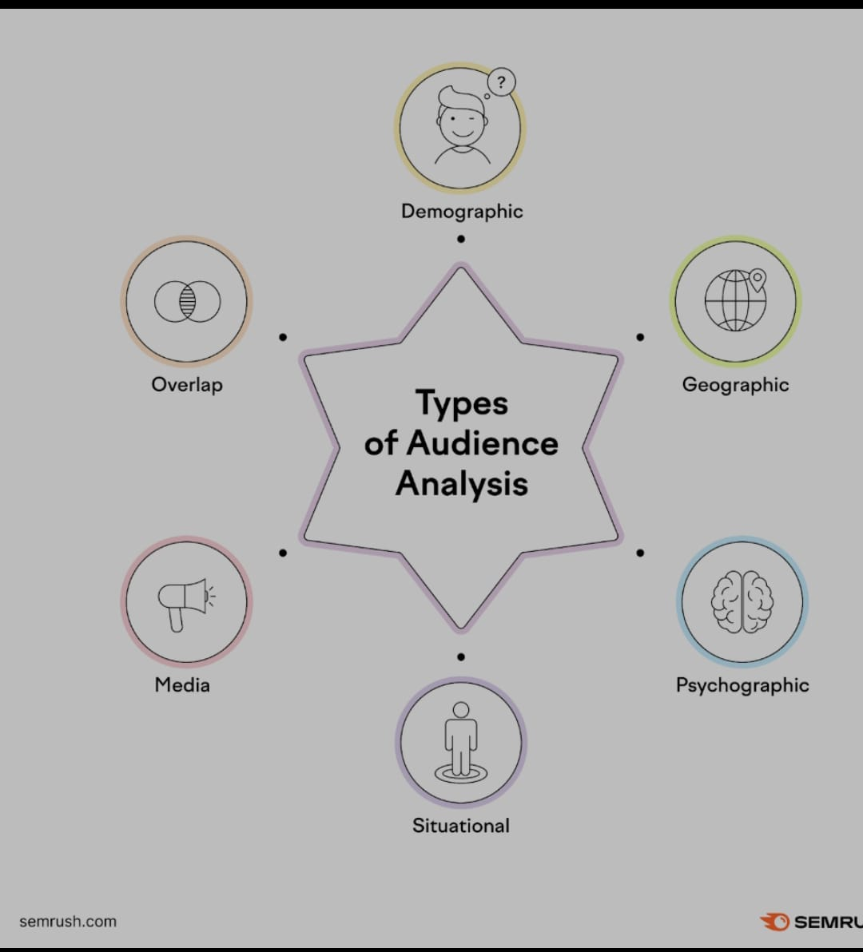

a. UML diagrams

1. Use Case Diagram
Purpose:
Shows how users interact with the system.
Actors:
User
Admin (optional)
Use Cases:
Register / Login
View movies
Rate movies
Get recommendations
Manage movie database (Admin)
Train ML model (Admin)

Explanation:
The user interacts with the system to view and rate movies. Based on this input, the system analyzes preferences and generates recommendations. The admin manages data and system maintenance.

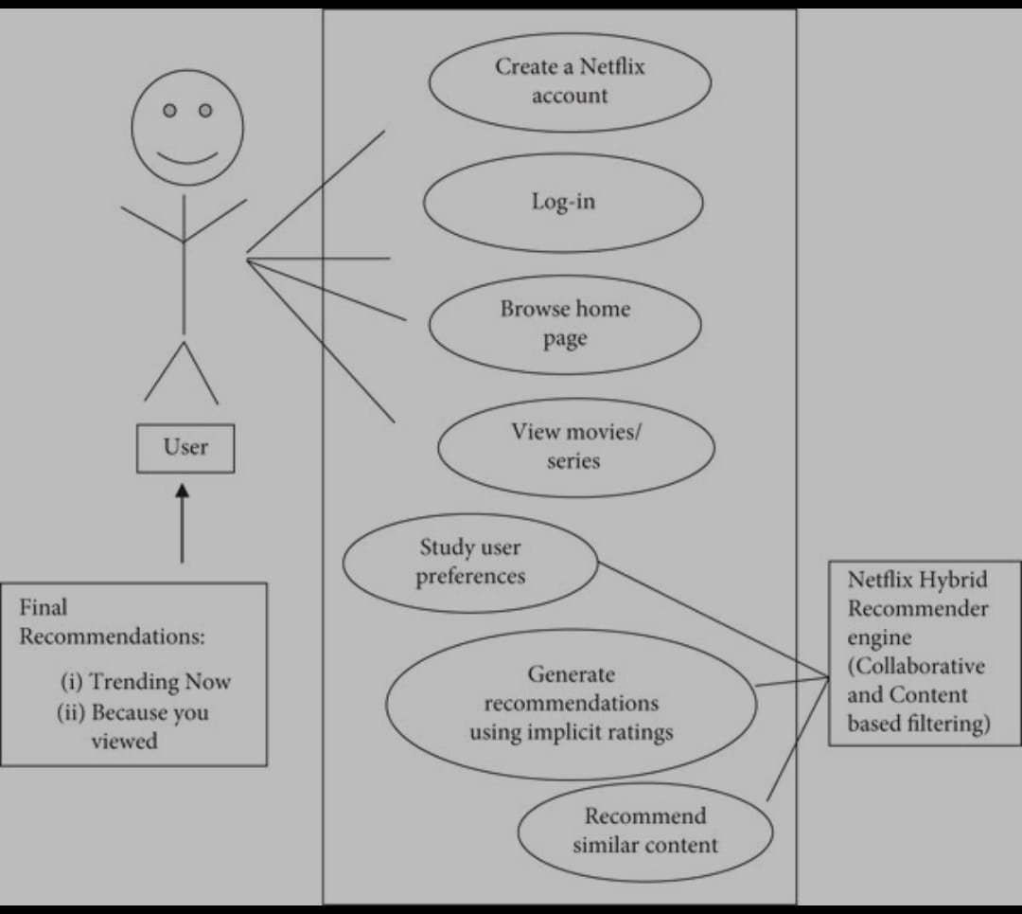
Fig 6.5: Sequence diagram

7. SYSTEM SPECIFICATION

1. Hardware Requirements
The hardware requirements for this project are minimal, making the system easy to implement and cost-effective.
- Processor: Intel Core i3 or higher
- RAM: Minimum 4 GB (8 GB recommended)
- Hard Disk: 100 GB free space
- Input Devices: Keyboard, Mouse
- Output Device: Monitor

2. Software Requirements
The software tools used in this project support machine learning and data analysis.
- Operating System: Windows / Linux
- Programming Language: Python
- IDE / Tool: Jupyter Notebook / PyCharm
- Database: MySQL / CSV files
- Libraries:
- NumPy
- Pandas
- Scikit-learn
- Matplotlib

3.Execution of Frontend
1. Frontend Design Overview
The frontend of the system acts as the interaction layer between the user and the recommendation system. It is designed to be simple, user-friendly, and visually appealing so that users can easily browse movies and view recommendations.

2. User Interface Components
The frontend consists of the following main components:
- Login and Registration page
- Movie browsing page
- Movie rating interface
- Recommendation display page
- Each component is connected to the backend, which processes data and returns results.

3. User Login and Registration
Users first access the system through the login or registration page. New users can create an account by providing basic details, while existing users can log in using their credentials. This helps the system uniquely identify users and track their preferences.

4. Movie Browsing and Selection
After logging in, users can browse the movie database. Movies are displayed with details such as title, genre, and release year. Users can search for movies or filter them based on genres.

5. Movie Rating and Interaction
Users can rate movies based on their interest or viewing experience. These ratings are sent to the backend and stored in the database. This interaction data is essential for analyzing audience preferences.

6. Recommendation Display
Based on user interactions and machine learning predictions, the frontend displays a personalized list of recommended movies. Recommendations are shown in a clear and organized manner, making it easy for users to select movies.

7. Data Flow Between Frontend and Backend
The frontend sends user input (ratings, searches, interactions) to the backend. The backend processes this data using machine learning models and returns recommended movie lists to the frontend for display.

8. Frontend Execution Outcome
The successful execution of the frontend ensures:
- Smooth user interaction
- Easy navigation
- Real-time display of recommendations
- Improved user experience

8 EXPERIMENTAL SETUP AND RESULTS

1. Dataset Description
The experiment was conducted using a movie dataset containing movie details and user interaction data. The dataset includes:
- Movie attributes such as title, genre, and release year
- User ratings and viewing history
- User–movie interaction records
- This dataset was suitable for analyzing audience preferences and training machine learning models.

2. Tools and Technologies Used
The experimental setup was implemented using the following tools:
- Programming Language: Python
- Environment: Jupyter Notebook
- Libraries: NumPy, Pandas, Scikit-learn, Matplotlib
- Storage: CSV files / MySQL database

3. Data Preprocessing
Before training the models, the dataset was preprocessed to improve quality:
- Missing values were handled
- Duplicate records were removed
- Categorical features were encoded
- Data was normalized
- This step ensured better learning and accurate predictions.

4. Model Implementation
The following machine learning approaches were implemented:
- Content-Based Filtering: Recommends movies based on movie features and user preferences
- Collaborative Filtering: Recommends movies based on similar users’ ratings
- Hybrid Model: Combines both approaches to improve recommendation accuracy
- The dataset was split into training and testing sets to evaluate performance.

5. Evaluation Metrics
The system performance was evaluated using standard metrics:
Accuracy
Precision
Recall
Mean Squared Error (MSE)
User satisfaction (based on recommendation relevance)

Results and Analysis
1. Recommendation Accuracy
The hybrid recommendation model showed better accuracy compared to individual methods. It effectively captured both user behavior and movie content features.

2. Comparison of Algorithms
- Content-based filtering provided personalized but limited recommendations
- Collaborative filtering improved diversity but suffered from cold start issues
- The hybrid approach balanced personalization and diversity.

3. Performance Outcome
- Improved recommendation relevance
- Reduced generic suggestions
- Better handling of large datasets
- Enhanced user engagement

9. CODING

Model Training Code (Collaborative Filtering – ML Based)

Step 1: Import Required Libraries
Copy code
Python
import pandas as pd
import numpy as np
from sklearn.model_selection
import train_test_split
from sklearn.metrics
import mean_squared_error
from sklearn.metrics.pairwise
import cosine_similarity

Step 2: Load Dataset
Copy code
Python
# Load movie ratings dataset
ratings = pd.read_csv("ratings.csv")
# columns: userId, movieId, rating

Step 3: Create User–Movie Matrix
Copy code
Python
user_movie_matrix = ratings.pivot
(
index='userId',
columns='movieId',
values='rating'
)

# Replace missing values with 0
user_movie_matrix.fillna(0, inplace=True)

Step 4: Train–Test Split
Copy code
Python
train_data, test_data = train_test_split
(
user_movie_matrix,
test_size=0.2,
random_state=42
)

Step 5: Compute User Similarity
Copy code
Python
user_similarity = cosine_similarity(train_data)
user_similarity_df = pd.DataFrame
(
user_similarity,
index=train_data.index,
columns=train_data.index
)

Step 6: Predict Ratings
Copy code
Python
def predict_ratings(user_movie_matrix,similarity_matrix):
mean_user_rating = user_movie_matrix.mean(axis=1)
ratings_diff = user_movie_matrix.sub(mean_user_rating, axis=0)
predictions = mean_user_rating[:, np.newaxis] + \
similarity_matrix.dot(ratings_diff) / \
np.abs(similarity_matrix).sum(axis=1)[:, np.newaxis]
return predictions

Step 7: Model Training
Copy code
Python
predicted_ratings = predict_ratings
(
train_data.values,
user_similarity
)

Step 8: Model Evaluation
Copy code
Python
# Convert to DataFrame
predicted_ratings_df = pd.DataFrame
(
predicted_ratings,
index=train_data.index,
columns=train_data.columns
)
# Calculate error
mse = mean_squared_error
(
train_data.values.flatten(),
predicted_ratings.flatten()
)

print("Mean Squared Error:", mse)

Result
Model learns user preferences using similarity
Generates personalized movie recommendations
Lower MSE indicates better prediction accuracy

10. EXECUTION SCREENSHOTS

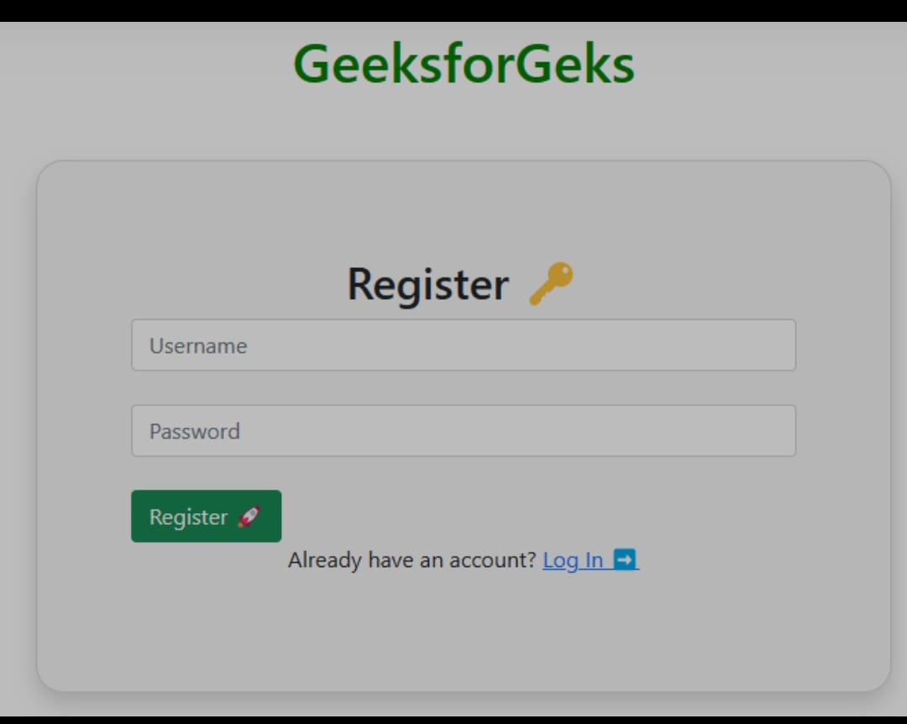

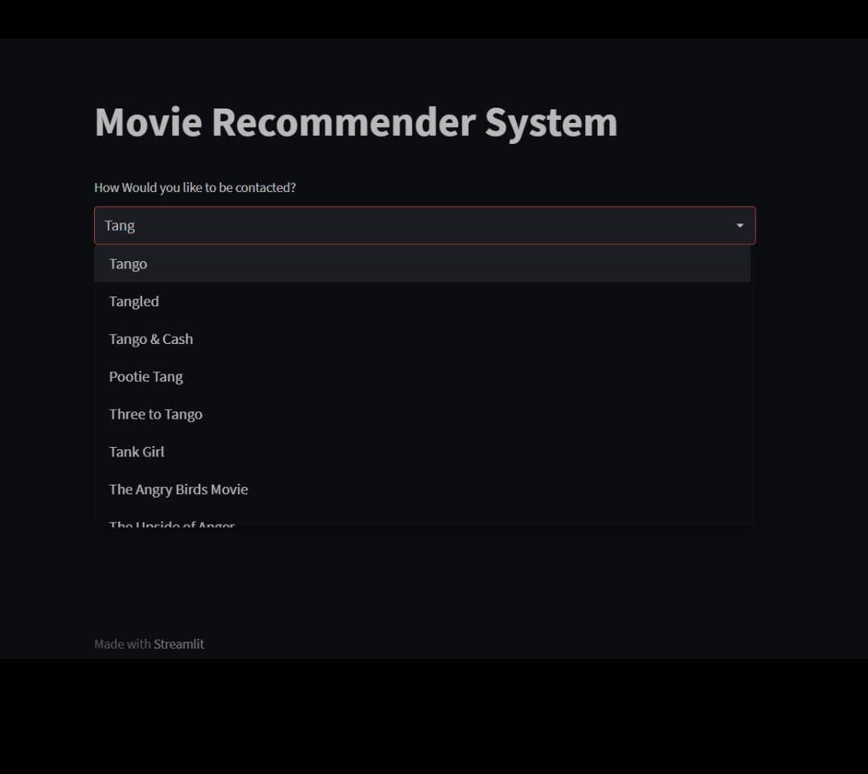

11 LIMITATIONS

1. Cold Start Problem
The system faces difficulty in recommending movies to new users or newly added movies due to the lack of sufficient interaction data such as ratings or watch history.

2. Dependency on Data Quality
The accuracy of recommendations depends heavily on the quality of the dataset. Missing values, biased ratings, or incorrect data can negatively affect the performance of the machine learning models.

3. Limited Dataset Size
If the dataset used is small or not diverse enough, the model may not generalize well to real-world scenarios, leading to less accurate recommendations.

4. Computational Complexity
Machine learning algorithms, especially collaborative and hybrid models, require significant computational resources. This can impact system performance for large-scale datasets.

5. Dynamic User Preferences
User interests change over time, but the system may not instantly adapt to these changes unless the model is retrained regularly.

6. Lack of Real-Time Recommendations
The current system may not support real-time updates, meaning recommendations may not immediately reflect the latest user interactions.

7. Limited Evaluation Metrics
The project mainly focuses on basic evaluation metrics such as accuracy or error rate and may not fully capture user satisfaction or recommendation diversity.

8. Scalability Issues
As the number of users and movies increases, the system may face scalability challenges. Handling large-scale data efficiently requires optimized algorithms and infrastructure, which may not be fully supported in basic implementations.

9. Data Sparsity Problem
In movie databases, many users rate only a few movies. This leads to sparse data, making it difficult for collaborative filtering models to find meaningful patterns and generate accurate recommendations.

10. Bias in Recommendations
The system may favor popular or frequently rated movies, leading to biased recommendations. Less popular or newly released movies may not receive enough visibility in the recommendation results.

11. Limited Context Awareness
The recommendation system may not consider contextual factors such as user mood, time of day, or social influence. Ignoring these factors can reduce the relevance of recommendations.

12. Overfitting Risk
Machine learning models may overfit the training data, especially when the dataset is small. This can reduce the model’s ability to perform well on unseen or real-world data.

13. Privacy Concerns
Collecting and analyzing user data such as watch history and ratings may raise privacy and security concerns. Ensuring proper data protection and user consent is a challenge.

12 FUTURE SCOPE

1. Integration of Deep Learning Models
The system can be enhanced by incorporating deep learning techniques such as neural networks and deep collaborative filtering. These models can learn complex user–movie relationships and improve recommendation accuracy.

2. Real-Time Recommendation System
Future versions of the project can support real-time recommendations by continuously updating user preferences based on live interactions, clicks, and watch behavior.

3. Hybrid Recommendation Enhancement
The hybrid recommendation approach can be further improved by dynamically adjusting the weight between content-based and collaborative filtering based on user behavior and data availability.

4. Sentiment Analysis of Reviews
Natural Language Processing (NLP) techniques can be applied to analyze user reviews and comments. Sentiment analysis can help understand audience emotions and improve recommendation quality.

5. Cold Start Problem Reduction
Advanced techniques such as demographic-based recommendations and transfer learning can be used to address cold start issues for new users and movies.

6. Multi-Language and Regional Support
The system can be extended to support multiple languages and regional movie industries, making it suitable for a global audience.

7. Cloud-Based Deployment
Deploying the system on cloud platforms can improve scalability, performance, and availability, enabling the system to handle large datasets and high user traffic.
8. Enhanced Evaluation Metrics
Future work can include advanced evaluation metrics such as diversity, novelty, and user satisfaction to better measure system effectiveness.

13 APPLICATIONS

1. Online Movie Streaming Platforms
The system can be used in movie streaming platforms to provide personalized movie recommendations based on user preferences, viewing history, and ratings. This helps users easily discover relevant movies and improves user engagement.

2. Digital Entertainment Portals
Audience preference analysis can be applied in entertainment websites and apps to organize content efficiently and suggest movies according to user interests.

3. Content Recommendation Systems
The project can be extended to recommend other digital content such as TV shows, web series, documentaries, and short films using similar machine learning techniques.

4. Marketing and Advertisement Targeting
Movie platforms can use audience preference insights to display targeted advertisements and promotional content, improving marketing effectiveness.

5. Film Production and Planning
Movie producers and studios can analyze audience preferences to understand popular genres, themes, and trends. This helps in planning future movie projects and investments.

6. Personalized User Profiles
The system can be used to build intelligent user profiles that adapt over time based on changing preferences and behavior.

7. Academic and Research Applications
The project can be used as a reference model for students and researchers studying machine learning, recommendation systems, and data analytics.

14 SYSTEM TESTING

1. Purpose of System Testing:
System testing is performed to verify that the complete movie recommendation system works correctly and meets the specified requirements. It ensures that all modules are integrated properly and function as expected.

2. Testing Environment:
The system testing was carried out in a controlled environment using:
Python programming language
Jupyter Notebook / IDE
Movie and user datasets
Machine learning libraries
This environment helped in validating both functional and non-functional requirements.

3. Types of Testing Performed:
a) Unit Testing
Each individual module was tested separately, such as:
Data loading module
Data preprocessing module
Model training module
Recommendation generation module
This ensures that each component works correctly on its own.

b) Integration Testing
After unit testing, all modules were integrated and tested together.
This verifies: Data flow between frontend, backend, and database
Proper interaction between ML model and recommendation output

c) Functional Testing
Functional testing checks whether the system performs the intended functions:
User login and interaction
Movie rating and data storage
Generation of personalized recommendations
All functions were tested using valid and invalid inputs.

d) Performance Testing
Performance testing evaluates the system’s behavior under different conditions:
Handling large datasets
Response time for generating recommendations
Model execution efficiency

e) Validation Testing
The system output was validated to ensure that recommendations are relevant and consistent with user preferences.

4. Test Cases (Sample)
Test Case
Description
Expected Result
Status
TC1
Load dataset
Dataset loaded successfully
Pass
TC2
Preprocess data
Clean dataset generated
Pass
TC3
Train ML model
Model trained without error
Pass
TC4
Generate recommendations
Personalized list displayed
Pass

15 CONCLUSION
This project successfully demonstrates the effective application of machine learning algorithms for audience preference analysis in a movie database. By analyzing user ratings, viewing history, and movie attributes such as genre, language, and popularity, the system is able to understand audience behavior and generate personalized movie recommendations accurately and efficiently. The results confirm that machine learning techniques can significantly enhance the recommendation process compared to traditional rule-based methods.
The proposed system addresses several limitations of conventional recommendation systems by incorporating intelligent techniques such as content-based filtering, collaborative filtering, and a hybrid approach. These methods help improve recommendation accuracy, enhance personalization, and increase overall user satisfaction. Experimental results indicate better prediction performance and more relevant recommendations, proving the effectiveness of the implemented models.
Furthermore, the project highlights the importance of machine learning in handling large-scale data and extracting meaningful insights from complex datasets in the entertainment industry. The system provides a strong foundation for building advanced real-world movie recommendation platforms that can adapt to user preferences and changing trends.
Although the current system has certain limitations such as dependency on data quality and lack of real-time updates, it offers significant scope for future enhancements. The system can be further extended by integrating real-time user behavior analysis, deep learning models, sentiment analysis from reviews, and improved scalability for large datasets. Overall, this project demonstrates the potential of machine learning-based recommendation systems and serves as a valuable contribution toward intelligent and personalized digital entertainment services.

REFERENCES

- Ricci, F., Rokach, L., & Shapira, B., Recommender Systems Handbook, Springer, 2015.
- Sarwar, B., Karypis, G., Konstan, J., & Riedl, J., “Item-Based Collaborative Filtering Recommendation Algorithms,” WWW Conference, 2001.
- Adomavicius, G., & Tuzhilin, A., “Toward the Next Generation of Recommender Systems,” IEEE Transactions on Knowledge and Data Engineering, 2005.
- Schafer, J. B., Konstan, J., & Riedl, J., “E-Commerce Recommendation Applications,” Data Mining and Knowledge Discovery, 2001.
- Aggarwal, C. C., Recommender Systems: The Textbook, Springer, 2016.
- MovieLens Dataset, GroupLens Research, University of Minnesota.
- Pedregosa et al., “Scikit-learn: Machine Learning in Python,” Journal of Machine Learning Research, 2011.
- Koren, Y., Bell, R., & Volinsky, C., “Matrix Factorization Techniques for Recommender Systems,” IEEE Computer, 2009.
- Python Software Foundation, Python Programming Language Documentation.
- Flask Documentation, Flask Web Framework for Python.

